# Supplementary build instructions for CAN4DC v6 for modification to v8

These are supplemental building Instructions for the CBUS Analogue DC Quad throttle (CAN4DC). These describe the changes to be made in order to build a CAN4DC v8 circuit on a v6-3 PCB.

Do take a few minutes to read right through these Instructions before commencing assembly and checking that you have the parts listed below.

Static Precautions are vital when handling the major Integrated Circuits, such as the PIC, and MCP2652 and MAXIM3485 which should be left in their protective bag or tube until instructed to install.

## Tools Required

* Soldering iron
* Solder
* 3mm flat bladed screwdriver
* Side cutters
* Saw and strip cutter or 4mm drill for stripboard
* Knife
* Hot glue gun

## Circuit diagram

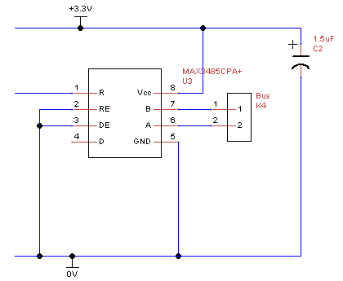

## Parts List

|  |  |  |  |
| --- | --- | --- | --- |
| **Reference** | **Quantity** | **Value** | **Notes** |
|  | 1 | Stripboard 7 strips by 13 holes |  |
| C2 | 1 | 47uF electrolytic 6V |  |
| U3 | 1 | MAX3485CPA |  |
|  | 1 | 8pin DIL socket |  |
| K4 | 1 | 2 position 0.2 in pitch screw-terminal block |  |
| U1 | 1 | PIC24HJ128GP502 | Programmed with EC compatible CAN4DC firmware |

In addition some think insulated wire is required to conned strips of the stripboard and to connect the stripboard to the CAN4DC PCB.

## Stripboard layout

The circuit occupies a piece of stripboard 7 strips by 13 holes.

3.3V

Clock

0V

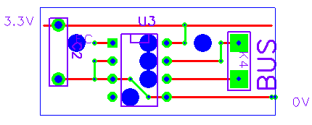

## Build and Check steps

1. Use a 4mm drill or special strip cutter to cut the copper strips at the six points indicated with large blue circles.
2. Fix the four wire jumpers shown by the green lines.
3. Fit bus connector K4 with the holes for the wires facing outwards.
4. Fit C2 electrolytic capacitor. Ensure the lead next to the 0 on the can goes to the bottom of the board.
5. Fit the U4 8pin DIL IC socket. Ensure the notch of the socket is at the top of the board.
6. Attach 50mm lengths of insulated wire for 3.3V, clock and 0V to the points indicated in the stripboard layout above.
7. Disconnect power from the CAN4DC.
8. **Taking anti-static precautions** remove the PIC from the CAN4DC and place in an anti-static storage.
9. Remove the ceramic resonator from the CAN4DC if fitted.
10. Connect the wires to the points indicated on the CAN4DC v6-3 PCB below. The 3.3V connection is made to the exposed lead of capacitor C2 near the edge of the board. The 0V connection is made to the centre pin of the ceramic resonator location. The Clock connection is made to pin of the ceramic resonator location which is nearest the centre of the board.  
    Leave sufficient length of wire so that the clock receiver can be tilted to allow access to the PIC.

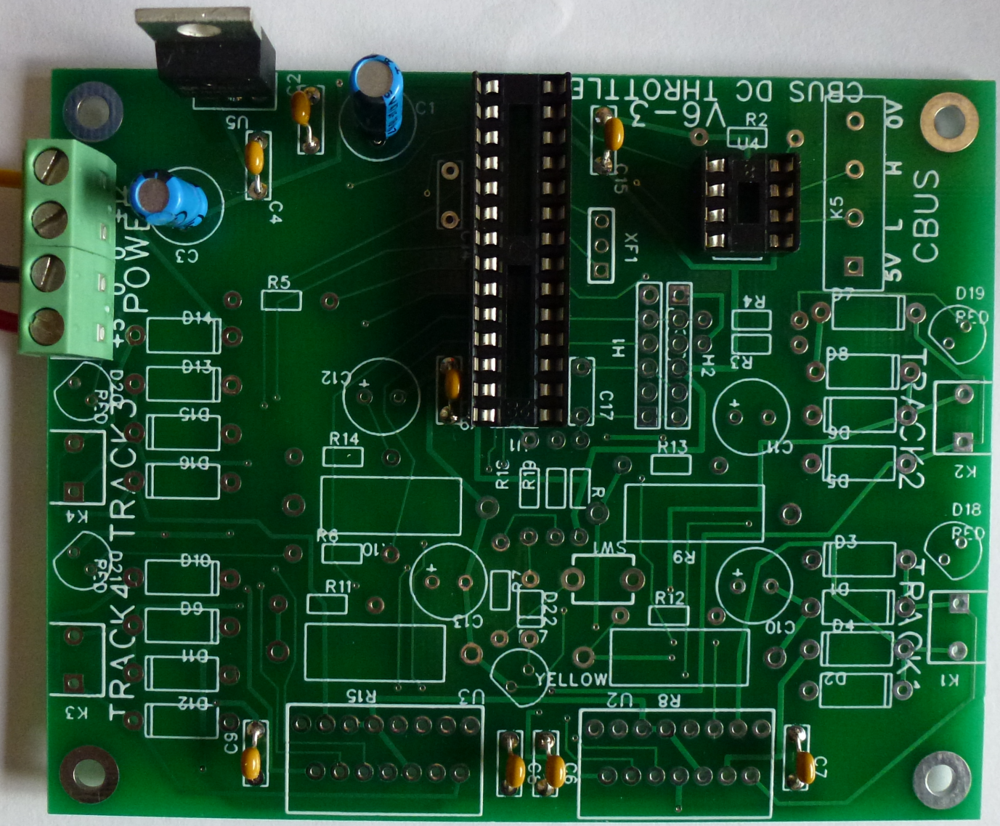

Clock

0V

3.3V

1. **Taking anti-static precautions** insert the MAX3485 integrated circuit.
2. If you have the facilities to program firmware onto the PIC using ICSP then **taking anti-static precautions** the original PIC can reinserted and then reprogrammed with EC compatible CAN4DC firmware. Otherwise a EC compatible re-programmed PIC replacement can be inserted whilst **taking anti-static precautions.**
3. The Clock receiver board can be glued to the top of the PIC to secure it into place.

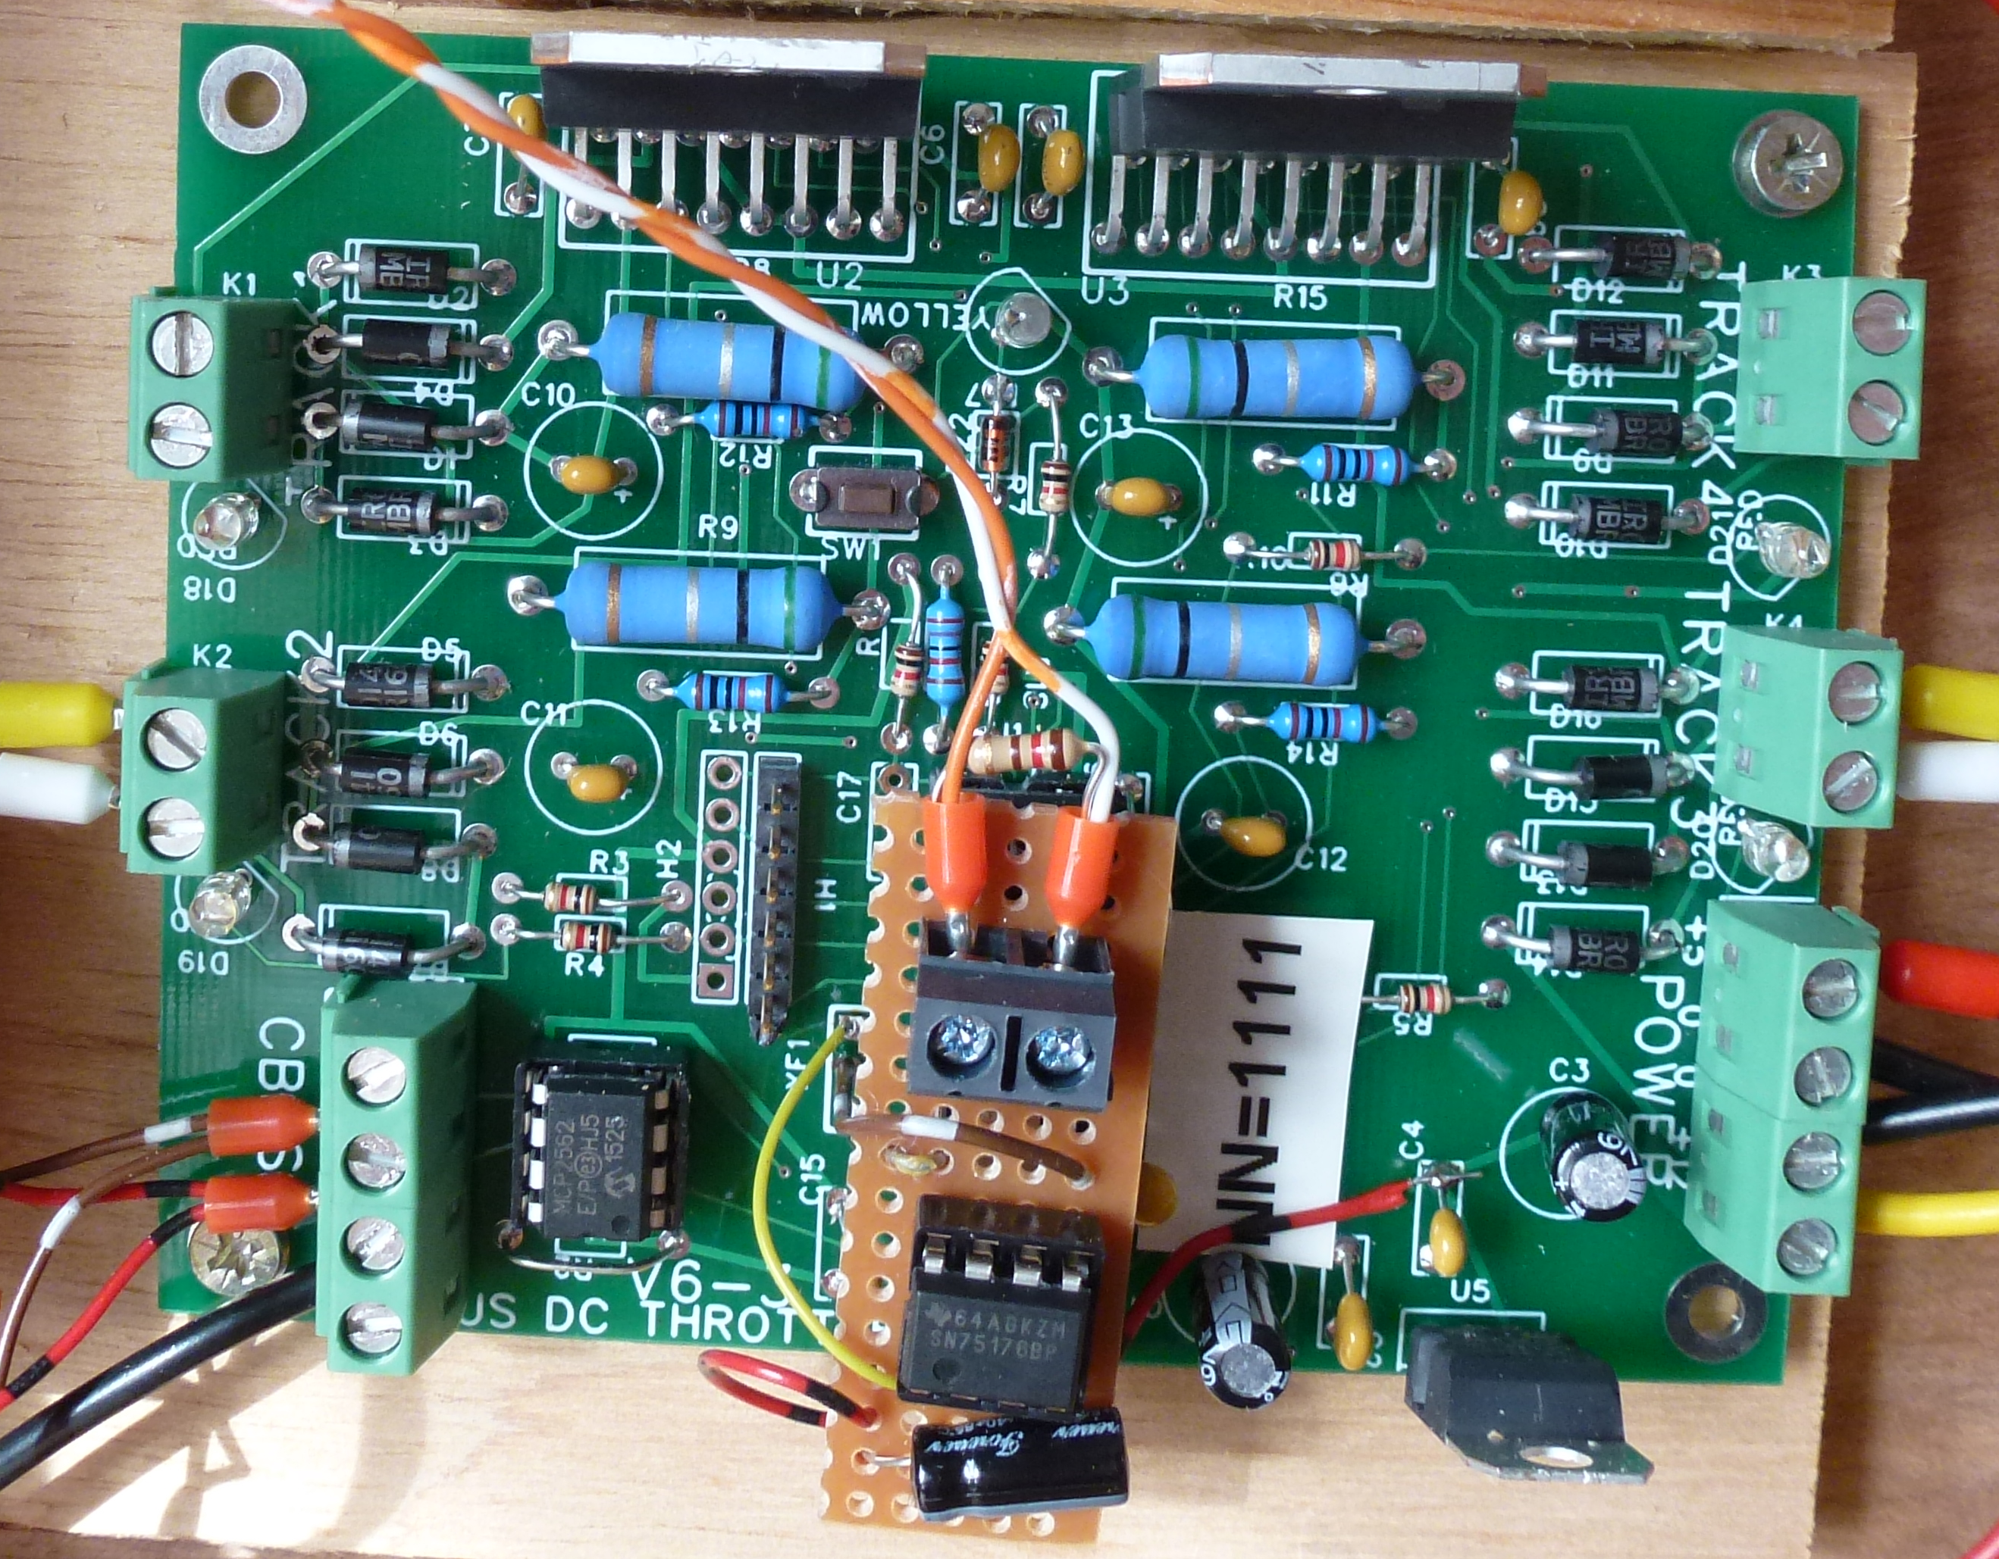

Build Complete